ASSOCIATION OF SCHOOLS OF PUBLIC HEALTH IN THE EUROPEAN REGION ASPHER
Strategic Plan 2020-2025: ASPHER 2025
Consultation
*** Please add feedback as needed where indicated in red ***
VISION AND VALUES 01
ASPHER 2025: CORE MISSION AND ENABLING AREAS 02
ASPHER 2025: STRATEGIC OBJECTIVES – ACTIVITIES AND OUTPUTS 03
ASPHER 2025: FEE SCHEME 10
ASPHER 2025: MEMBERSHIP BENEFITS AND SERVICES OFFER 11
VISION AND VALUES
The Association of Schools of Public Health in the European Region (ASPHER) is the key independent European organisation dedicated to strengthening the role of public health by improving education and training of public health professionals for both practice and research. ASPHER is a membership organisation of institutions, spread across the EU and wider across the WHO European Region, which are collectively concerned with the education and training, and professionalism, of those entering and working within the public health workforce.
The vision of the Association concentrates on the improvement of population health outcomes and the strengthening of professional identity in public health, and thus its main functions include: (1) To support the professionalisation of the public health workforce in Europe, whilst respecting the diversity of national and regional contexts in which each school of public health operates, and thus; (2) To sustain capacity building in public health, so that it balances with national and European population health challenges and threats, and is supported by best standards of public health education and training, scientific research, and practice.
Our values: (1) Member-focused – ASPHER’s strength is in its members, serving its members’ needs is ASPHER’s first priority; (2) Diversity – ASPHER supports, enjoys and gains vitality from diversity among its membership; (3) Integrity – ASPHER acts as a whole, undivided and led by a firm ethical framework and respect; (4) Meaningful work – ASPHER maintains focus ensuring coherent action; (…).
Please provide feedback, comments or reflections here on ASPHER’s vision and values as outlined above. Are there any values that were not listed here that you feel would be important to guide ASPHER 2025 strategy?
………………………………………………………………………………………………………………………………………………………………………………………………………………………………………………………………………………………………………

ASPHER 2025: CORE MISSION AND ENABLING AREAS
The ASPHER 2025 Core Mission Areas correspond with the main functions of schools of public health, including: (1) Education & Training; (2) Research & Knowledge; and (3) Service & Work with local communities. The following Enabling Areas complement the strategic agenda of the Association: (A) Membership & Governance; (B) Young Generation: Students & Alumni; (C) Public Health Workforce Professionalisation; and (D) Partnership & Global Collaboration. See figure below for the ASPHER 2025 graphic representation.
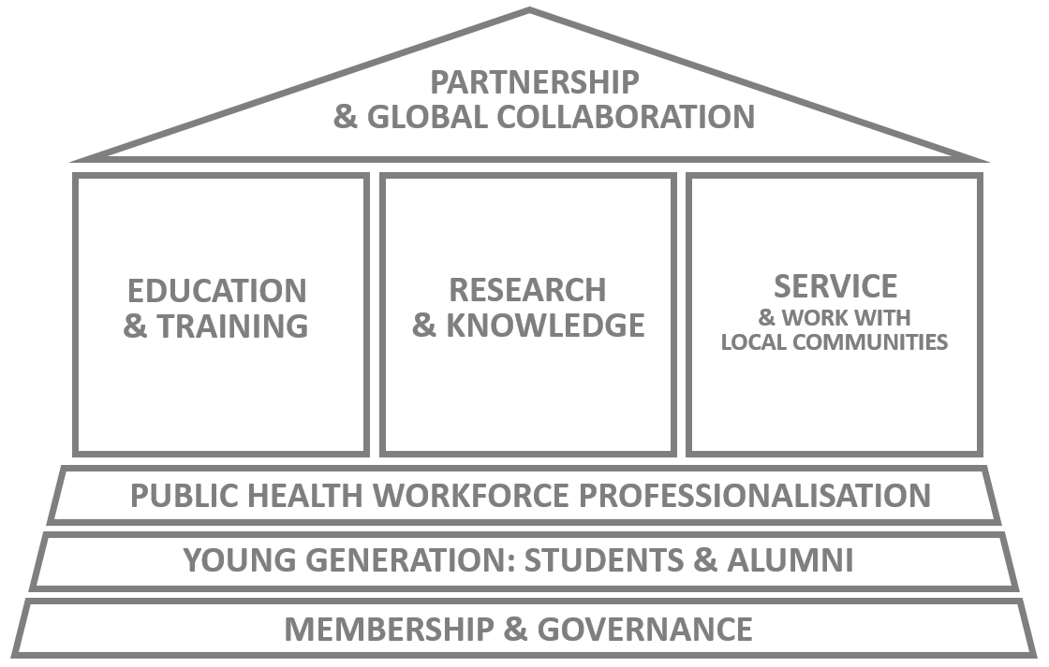
Please provide feedback, comments or reflections here on ASPHER’s 2025 Core Mission Areas.
………………………………………………………………………………………………………………………………………………………………………………………………………………………………………………………………………………………………………
Please provide feedback, comments or reflections here on ASPHER’s 2025 Enabling Areas.
………………………………………………………………………………………………………………………………………………………………………………………………………………………………………………………………………………………………………
Please provide feedback, comments or reflections here on the ASPHER 2025 graphic representation.
………………………………………………………………………………………………………………………………………………………………………………………………………………………………………………………………………………………………………

ASPHER 2025: STRATEGIC OBJECTIVES – ACTIVITIES AND OUTPUTS
Core Mission Areas
A shared strategic objective across the Core Mission Areas of the ASPHER 2025 agenda is for the Association to become a focal point with a brokering role for its members to support the three mandatory functions of schools of public health: Education & Training, Research & Knowledge, Service & Work with local communities.
The Association will aim to achieve that by setting up the Hub initiative for each of the three Core Mission Areas, i.e.: (1) Public Health Training Hub; (2) Public Health Knowledge Generation Hub; and (3) Public Health Community Engagement Hub.
Each of these will be composed of two elements:
- An online toolkit – being an exclusive component of each and every Hub individually;
- A dynamic element focusing on specific activities “hosted” by the given Hub but serving the context of other areas within the core mission and enabling domains as well, falling within the following three categories respectively: (1) short courses (for the Public Health Training Hub); (2) surveys, data bank and guidelines (for the Public Health Knowledge Generation Hub; and (3) This Is Public Health – Europe campaign and ASPHER’s position statements (for the Community Engagement Hub).
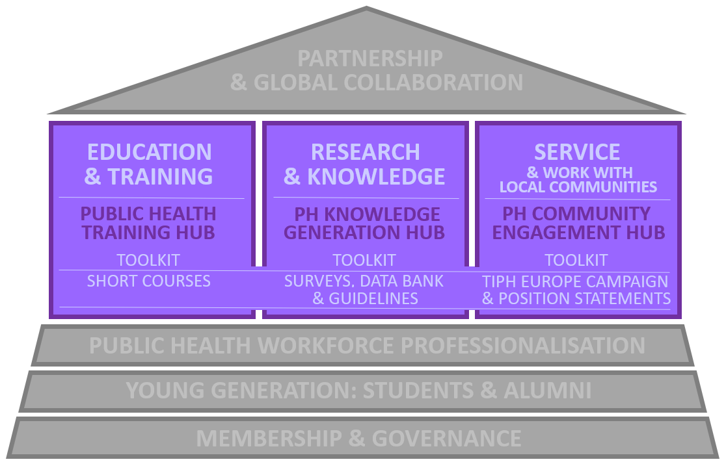
Please provide feedback, comments or reflections here regarding the Hub Initiative.
………………………………………………………………………………………………………………………………………………………………………………………………………………………………………………………………………………………………………

Selected functionalities of the Public Health Training Hub toolkit include: directory of available continuing professional development (CPD) in PH/training offerings, pool of experts*, and competency-based curriculum creator. Under the short courses component, selected possible training include: Schools of Public Health and Public Health Programmes (SPHs/PHPs) leadership and management*, PH crash course; and/or with a focus on other strategy areas: training for PhD supervisors* (Research & Knowledge); training for SPHs/PHPs engaging with the media* or training for advocacy (Service & Work with local communities); training for building up PH capacity and PHW professionalisation (Public Health Workforce Professionalisation); and ASSETS – Andrija Stampar Summer Educational and Tutoring School (Young Generation: Students & Alumni).
Selected functionalities of the Public Health Knowledge Generation Hub toolkit include: support to project implementation including bringing together partners for bids and joint publication efforts*, and a good practice repository. Under the surveys, data bank and guidelines (“intelligence”) component, selected possible areas of focus include: new sources of data and methods for public health (with case studies*); and/or with a focus on other strategy areas: innovation in teaching and learning, interprofessional Public Health Education and Training (PHET) for the Health in All Policies and Sustainable Development Goals (HiAP/SDGs) agenda, diversity in PHET (with case studies*) (Education & Training); social accountability and PHET, SPHs as corporate citizens, working with the media (with case studies*) (Service & Work with local communities); interprofessional values, being advocates, cultural competencies, professional regulation (with case studies*) (Public Health Workforce Professionalisation); and mobilization of student and alumni communities (with case studies*) (Young Generation: Students & Alumni).
Selected functionalities of the Public Health Community Engagement Hub toolkit include: support to schools engaging in work with local communities*, and a good practice repository. The Public Health Community Engagement Hub will also host the This Is Public Health – Europe campaign* and the Association’s position statements*, which serve the organization’s broader strategy agenda.
Please provide feedback, comments or reflections here regarding the functionalities of the Public Health Hub toolkits and their other elements (short courses, surveys, data banks and guidelines; TIPH Europe campaign and position statements); should there be other specific items included? Is it appropriate to keep the items marked with (*) as exclusive activities and outputs to ASPHER Members (in direct membership arrangement) only?
………………………………………………………………………………………………………………………………………………………………………………………………………………………………………………………………………………………………………

Enabling Areas: Membership & Governance
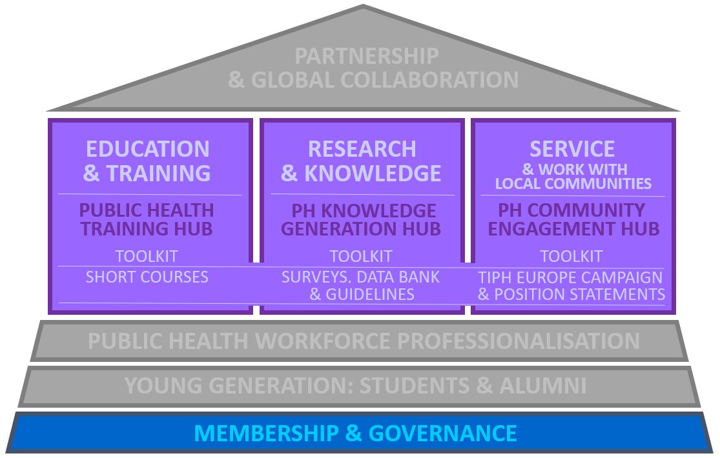

Membership & Governance is the foundational enabling area under the ASPHER 2025 agenda. It assumes a number of critical actions to secure the new strategy implementation:
Statutes & Bylaws review (rules of procedure), including roles and responsibilities within the Association’s governance (ASPHER General Assembly, ASPHER Executive Board and Task Forces, ASPHER Director and Secretariat).
Financial routine review, including budgeting and cash-flow, transparency statement – i.e., ASPHER’s guiding principles concerning partnership, sponsorship, and conflict of interest.
Agenda planning routine review, including guidelines for the formulation of presidency priorities, annual work plans, and 5-year strategies; matching capacity.
Membership policy review, including membership benefits and services offer, the fee structure, and other relevant items such as the ASPHER policies on membership capacity building (solidarity scheme and individual country cases); engagement in member and other projects; and on the Association’s collaborating centres, working groups and networks of interest. See the fee scheme and membership benefits and services offer for further consultation later in the document.
ASPHER PEER positioning as a flagship service of the Association to members. Through the Public Health Education European Review (PEER), ASPHER offers a cadre of expertise on the process of international peer review and standards; to evaluate and provide recommendations for planning and improvement. This is not an accreditation service, but it is a flexible offer that may be tailored to specific development and pedagogic/other project needs as identified by Schools of Public Health and Public Health Programmes (SPHs/PHPs).
Public Health Reviews (PHRS) positioning as a society journal.
ASPHER Deans’ & Directors’ Retreat positioning as a key membership event of the Association, including development of a handbook to guide the organisation of the event under a new/enhanced format based on past years’ experience.
ASPHER Honours Committee positioning as the Association’s “reflection chamber”, composed of the ASPHER past presidents and the Andrija Stampar Medallists.
ASPHER Student & Alumni Network setup, to address the context of young generation and early career professionals in public health via communities closest to the Association’s membership, including activities detailed in the following section.
Awards & Distinctions review, including policies referring to the Andrija Stampar Medal and ASPHER Good Practice Award in Public Health Education and Training (PHET); with additional awards/distinctions to be considered.
ASPHER website & social media channel positioning, achieving greater impact.
Please provide feedback, comments or reflections here regarding the Membership & Governance enabling area.
………………………………………………………………………………………………………………………………………………………………………………………………………………………………………………………………………………………………………
Public Health Reviews has had some success (with listing in PubMed and Scopus), however it is struggling financially and requires work capacity that the Association can no longer support as part of the regular agenda. Would your school/programme be interested in contributing financially or with in-kind editorial support to the recovery of PHRS?
………………………………………………………………………………………………………………………………………………………………………………………………………………………………………………………………………………………………………

Enabling Areas: Young Generation – Students & Alumni
A representative of ASPHER’s SAN will join the ASPHER Executive Board in an advisory capacity.
Activities under the Young Generation – Students & Alumni enabling area of the ASPHER 2025 agenda form the portfolio of the Association’s Students & Alumni Network (SAN), and include:
ASPHER Advance Forum*, hosted by the annual Deans’ & Directors’ Retreats.
ASPHER Young Researchers’ Forum*, hosted by the annual European Public Health (EPH) Conference as standard, possible other contexts such as Digital Public Health (DPH) and/or European Scientific Conference of Applied Infectious Disease Epidemiology (ESCAIDE).
ASPHER Internship & Fellowship Schemes*.
ASSETS (Andrija Stampar Summer Educational & Tutoring School).
ASPHER SAN consultancy service* on how to mobilize student and alumni communities (stand alone and as an integrated part of the PEER service).
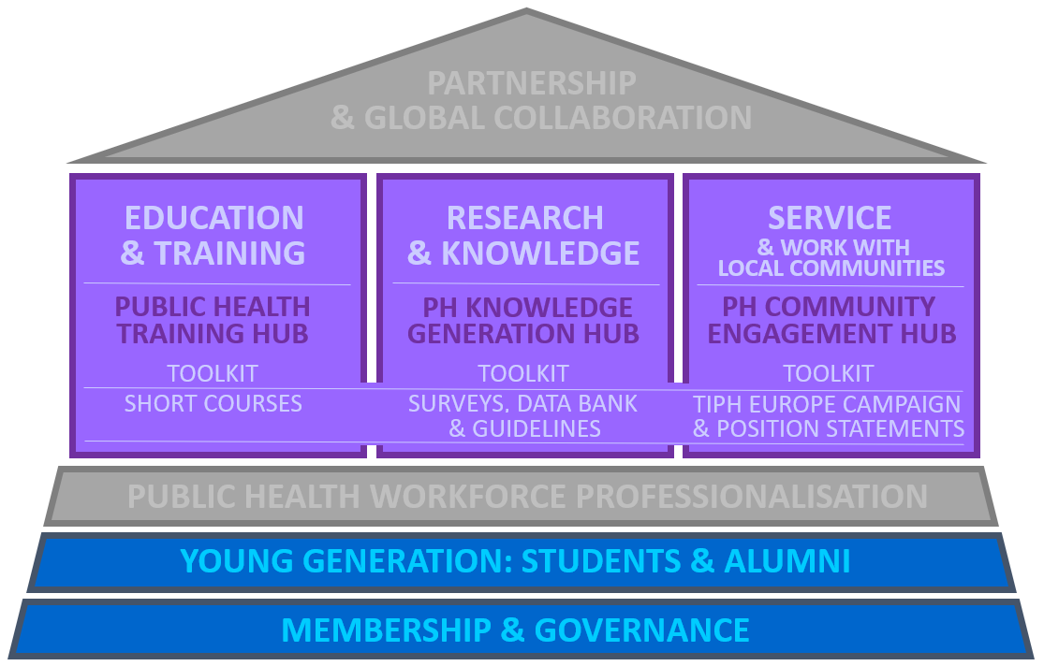

Please provide feedback, comments or reflections here regarding the Young Generation: Students & Alumni enabling area.
………………………………………………………………………………………………………………………………………………………………………………………………………………………………………………………………………………………………………

Enabling Areas: Public Health Workforce Professionalisation
The final enabling area of the ASPHER 2025 base structure refers to the Public Health Workforce Professionalisation agenda, a large and complex area including:
Public Health Competences Programme, the Association’s flagship programme with wide-range functionality via the Core Curriculum (academic focus) and the Competency Framework for the Public Health Workforce in the European Region (practice focus).
Public Health Education and Training (PHET) Accreditation – APHEA, the Agency founded and led by ASPHER, serving the Association’s members and contributing to its broader agenda on the PHW professionalisation and PEER service; also to share/develop joint ASPHER-APHEA recommendations for bachelor, master, doctoral programmes and professional training standards.
Professional Credentialing System setup, one of the most challenging agenda items under the ASPHER 2025 strategy aiming at development of Certified in Public Health (CPH) – Europe scheme, taking advantage of its integration with the relevant mechanisms at the global level allowing for the recognition of professional standards in public health across regions.
Code of Conduct draft, complementing relevant efforts under the PHW professionalisation agenda by development and wide endorsement of a Code of Ethics and Professional Conduct for the Public Health Workforce in the European Region.
Public Health Systems Strengthening and Professionalisation Centre, ASPHER-led structure to provide consultancy services to members and other stakeholders including countries via the Professionalisation Road Map roll out (implementation-evaluation-feedback).
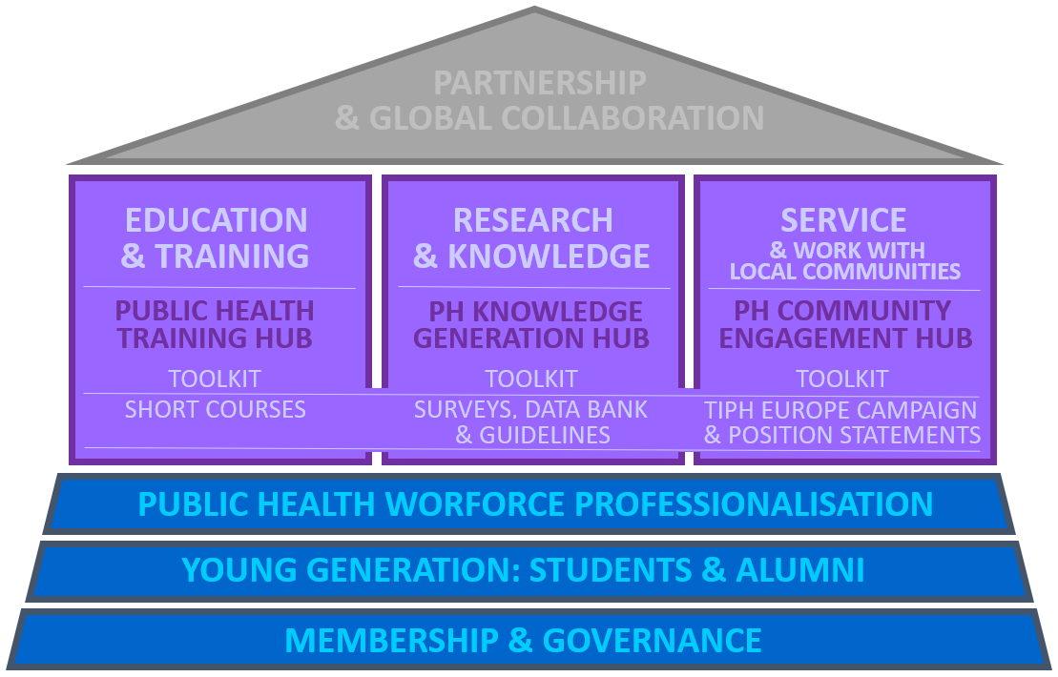
Please provide feedback, comments or reflections here regarding the Public Health Workforce Professionalisation enabling area.
………………………………………………………………………………………………………………………………………………………………………………………………………………………………………………………………………………………………………

Enabling Areas: Partnership & Global Collaboration
The final enabling area, crowning the ASPHER 2025 agenda refers to Partnership & Global Collaboration. The general approach here is two-fold:
- Europe-level via the WHO EURO Coalition of Partners (COP) and the EU Health Policy Platform (HPP);
- Global-level via the Global Network for Academic Public Health (bringing together ASPHER-like networks from all regions) and via the World Federation of Public Health Associations (WFPHA).
Selected core partnerships and collaboration arrangements within the individual areas of ASPHER 2025 include:
For Education & Training: OMI Salzburg Seminars of the American Austrian Foundation (OMI-AAF), and the Agency for Public Health Education Accreditation (APHEA).
For Research & Knowledge: European Observatory on Health Systems and Policies (OBS), and the European Public Health Conference of the European Public Health Association (EPH-EUPHA).
For Service & Work with local communities: This Is Public Health (global campaign), and the European Public Health Alliance (EPHA).
For all three of the Core Mission Areas – serving the Hub initiative, but also to the selected activities under the Enabling Areas: Public Health Reviews (PHRS).
For Young Generation – Students & Alumni: European Network of Medical Residents in Public Health (Euronet MRPH), and other relevant student and young professional networks such as the Europubhealth Students and Alumni Association (EPHSA).
For Public Health Workforce Professionalisation: WHO Regional Office for Europe (WHO EURO), and the International Association of National Public Health Institutes (IANPHI).
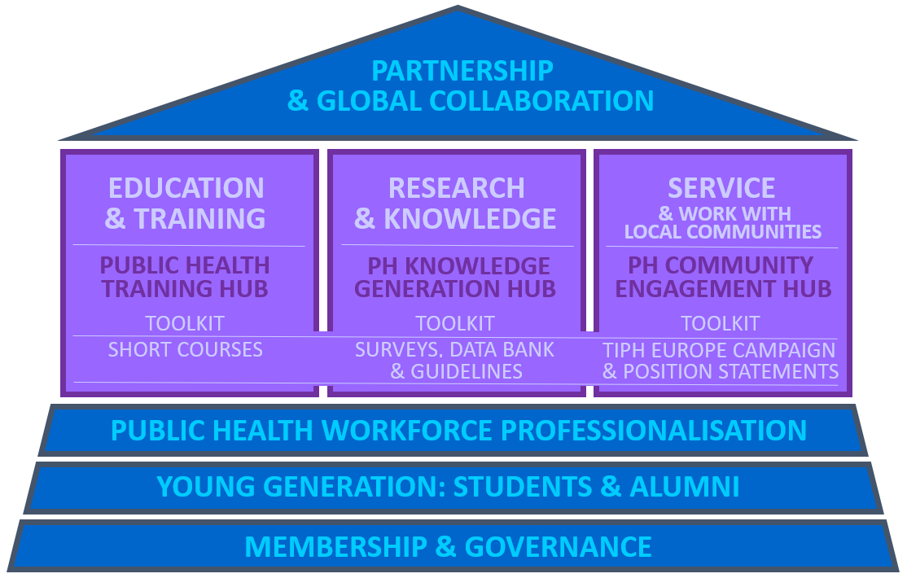
Please provide feedback, comments or reflections here regarding the Partnership & Global Collaboration enabling area.
………………………………………………………………………………………………………………………………………………………………………………………………………………………………………………………………………………………………………

ASPHER 2025: FEE SCHEME
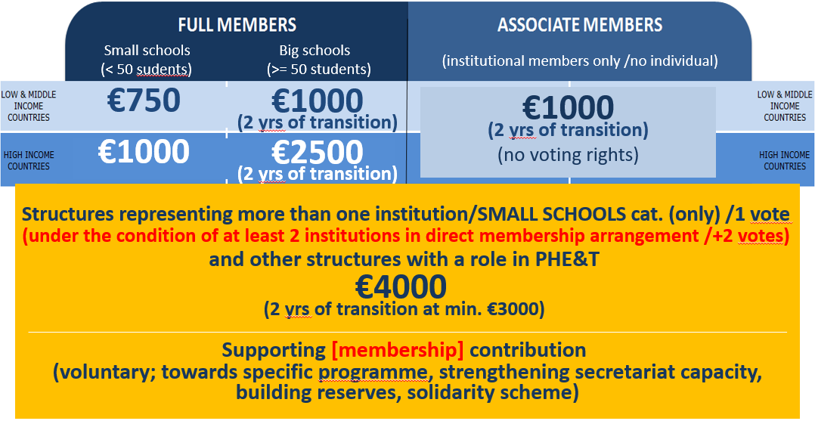
Key features of the new fee structure proposal:
- Full Members fee: 750 – 2500 EUR; calculated based on 2 criteria: (1) Size of the school; and (2) GDP of the country of establishment.
- Associate Members fee: flat rate of 1000 EUR.
Institutional members only, i.e. schools from outside of the WHO European Region. Individual Membership will no longer be offered.
- Special fee category for structures representing more than one institution (all of which must fall within the small school size category and under the condition of at least 2 institutions remaining in direct membership arrangement with the Association); and other structures with a role in Public Health Education and Training (PHET): 4000 EUR.
- Two years of transition period for members that fall within the higher fee category under the new fee structure proposal.
- Supporting membership contribution – a voluntary contribution/donation separate from the mandatory membership fee scheme; towards a specific programme, strengthening secretariat capacity, building reserves and/or solidarity scheme.
Please provide feedback, comments or reflections here regarding the ASPHER 2025 fee structure.
……………………………………………………………………………………………………………………………………………………………………………………………………
Please provide your reflection on how you would define the size of a school. For example, if based on overall number of students, what would be the upper limit in number of students to be considered a “small” school?
……………………………………………………………………………………………………………………………………………………………………………………………………
ASPHER 2025: MEMBERSHIP BENEFITS AND SERVICES OFFER
(to be refined with additional details and logical order to distinguish between benefits and services)
Being a part of the ASPHER network – membership community.
Active and passive voting rights on Association’s matters /General Assembly.
Taking part in consultation and further implementation of ASPHER agenda
(including strategy and annual work plans).
Joint project opportunities with the Association; also ASPHER engaging in projects and other initiatives only if membership link/interest is established.
Invitation to Annual Retreat.
Access to ASPHER PEER service.
Access to ASPHER working groups and networks of interest.
Possibility to apply for the ASPHER collaborating centre status.
Access to full functionality of the ASPHER Hub Initiative (PH Training Hub, PH Knowledge Generation Hub, and PH Community Engagement Hub), including toolkits, short courses, surveys, data banks, guidelines, campaigns and position statements.
Access to ASPHER Student & Alumni Network – SAN (including Advance Forum, Young Researchers’ Forum, Fellowship & Internship Schemes).
Access to This Is Public Health – Europe campaign.
Access to ASPHER partnerships, including the Global Network for Academic Public Health.
Access to ASPHER awards and distinctions (passive and active voting status).
Access to ASPHER's premises in Brussels.
Access to the online platform – online community membership at aspher.org, and to other communication platforms of the Association (journal, seasonal newsletters, social media…).
Access to ASPHER consultancy services via the Association-led Public Health Systems and Professionalisation Centre and/or Students and Alumni Network.
Discounts to publish in Public Health Reviews (PHRS).
Discounts in APHEA rates and the validation service at the point of entry to the Association, also access to the APHEA pool of reviewers.
Discounts in EPH Conference rates, and other benefits linked to possible exposure in the context of the conference (joining ASPHER-led sessions, exhibition booth…).
Please provide feedback, comments or reflections here regarding the ASPHER 2025 membership benefits and services offer. Are there any services that were not listed here that you feel would be important for ASPHER to offer to Members or that would be of interest to your school/programme?
………………………………………………………………………………………………………………………………………………………………………………………………………………………………………………………………………………………………………

Activities and outputs remaining exclusive to ASPHER members are marked with “”
Activities and outputs remaining exclusive to ASPHER members are marked with “”

